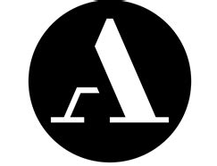
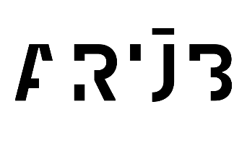

Data Agreement

An agreement is made effective from this date, DD.MM.YYYY, in order to define the terms of use of any and all digital data associated with specimens curated by the Institute of Archaeology, Czech Academy of Sciences, Brno and microCT scanned by the Max Planck Institute for Evolutionary Anthropology in Leipzig.

The agreement concluded between the Institute of Archaeology, Czech Academy of Sciences, Brno (IA BRNO CAS):
Čechyňská 363/19, 602 00, Brno
IČO: 680 81 758

and the Licensee:

Full Name: | Click or tap here to enter text.
Address of Affiliated Institution: | Click or tap here to enter text.
Email: | Click or tap here to enter text.

Research Project Title:

Click or tap here to enter text.

Research Project Description:

Click or tap here to enter text.

Terms:
- The term 'CT scan' in this agreement refers to all or part of a requested CT volume, as well as to any images or objects derived from these (e.g., surface models), represented in any digital or physical format.
- The IA Brno CAS, as copyright holder of the CT scans, grants permission to the licensee for the use of the CT scans for the research project described above; including any associated educational and/or scientific presentations. The CT scans are provided for scientific use by the institutional research group of the licensee only. The licensee agrees not to provide the CT scans to any third party, including other researchers and institutions.
- Use of digital data derived from the CT scans (e.g., images of surface renderings, surface models, movies) by the licensee is permitted for research (including the creation of digital media associated with the publication of research); however, they cannot be disseminated to third parties or used for commercial publications. The licensee is permitted to produce 3D prints from the CT scans only for personal use in research and teaching. Under no circumstances can 3D prints derived from the CT scans be disseminated to third parties or used for commercial purposes.
- The use of the digital data for additional projects not listed on this Agreement requires written permission from the IA Brno CAS. If the licensee is unsure whether a new project falls within the scope of the original proposed project (described above) they must contact the IA Brno CAS for guidance.
- Any publication of the CT scans and/or study of the CT scans will acknowledge “IA Brno CAS and the curator in charge".
- The IA Brno CAS has the right to deny the licensee the use of the CT scans in the event this agreement is broken by the licensee. Failure to adhere to the stipulations in the agreement could result in the licensee being refused future access to all digital data of the IA Brno CAS.
- Information about the CT scans is thought to be correct at the time of publishing; any errors will be corrected without notification and do not annul the terms of this agreement.

Accessing CT scans:
- The licensee should select in the tables below the CT scans they would like to purchase for use in the described research project. This completed and signed agreement should be emailed to: Dr. Martin Novak (novak@arub.cz) for evaluation.
- Upon acceptance of the proposed project the CT scans to be transferred to the licensee.

Digital Signature:
The typed / written signature of the Assignee indicates that all stipulations mentioned in this Agreement have been read, are clearly understood, and will be adhered to.

Date: DD/MM/YYYY Name: Click or tap here to enter text.

