Lab activity: how the human femur is adapted to bipedalism?

The 3D models you will need for this lab:
- human adult femur;
- chimpanzee adult femur;
- gorilla adult femur.

The most frequent locomotor behaviour in chimpanzees and bonobos is quadrupedal knuckle-walking, but they also engage in several other terrestrial as well as arboreal behaviours, including vertical climbing, leaping, bipedalism and suspension. Gorillas engage most frequently in terrestrial knuckle-walking and practice variable degrees of arboreality, depending on habitat and body size. Humans are the only obligate terrestrial bipedal ape and are unique in that both the hips and knees remain relatively extended during the gait cycle, rather than a more bent-hip and bent-knee gait that is observed in other great apes (Fig. 1).

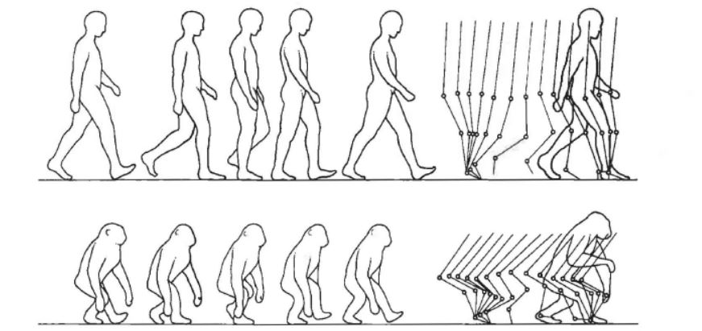
Figure 1. Human and chimpanzee patterns of bipedal walking (extracted from Aiello & Dean, 1990).

Bipeds have adapted a number of interdependent morphological characteristics that solve the challenges posed by habitual bipedalism. When compared to quadrupedal apes, the human femur shows anatomical features well adapted for bipedalism.

1) Anatomical structures of the femur

Using the surface models of a human, a chimpanzee and a gorilla femur, identify the following anatomical structures in each model and label the Figure 2 accordingly.

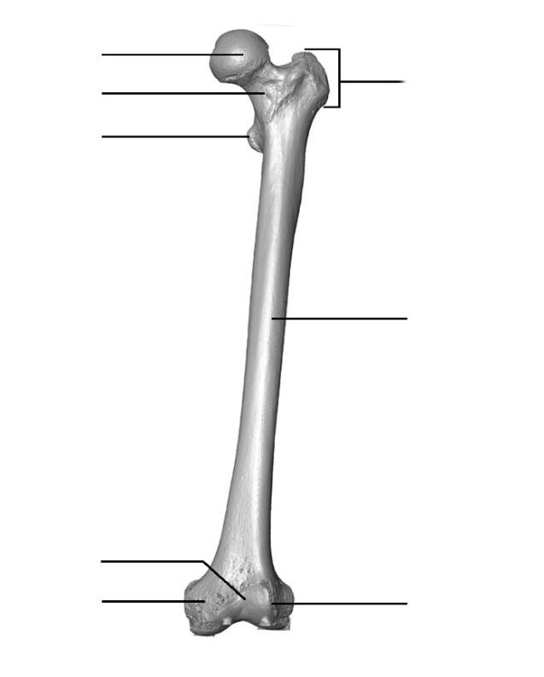
1. Head

2. Neck

3. Lesser trochanter

4. Greater trochanter

5. Shaft

6. Patellar surface

7. Medial epicondyle

8. Lateral epicondyle

Figure 2. Anterior view of a human left femur.

2) Proportions of the body weight.

On each 3D model, measure the supero-inferior diameter of the femoral head and the medio-lateral diameter of the subtrochanteric region (see Fig. 3) and record it in the table.
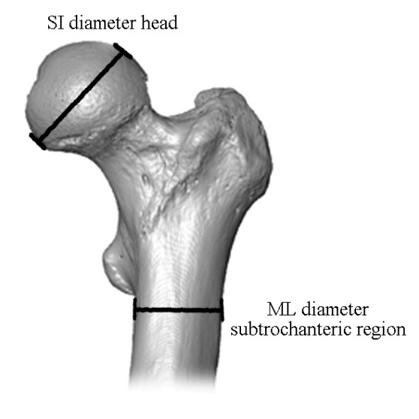

Species | SI diameter  (mm) | ML diameter  (mm)
Human
Chimpanzee
Gorilla

Figure 3. Supero-inferior diameter of the head and medio-lateral diameter of the subtrochanteric region.

Plot the supero-inferior diameter of the femoral head and the medio-lateral diameter of the subtrochanteric region for each specimen on the graph below (Fig. 4).

Which species has the relatively largest femoral head? What do you think this reflects? ______
__________________________________________________________________________

Figure 4. Scatterplots of the supero-inferior diameter of the femoral head against the medio-lateral diameter of the subtrochanteric region of a human, a chimpanzee and a gorilla sample.

Curvature of the bone shaft is thought to restrict the direction of bending experienced by the bone when it is loaded. In contrast, a straight bone subjected to the same loads will have no restriction on the range of its bending direction and hence it is more difficult to predict the direction of bending. A more pronounced curvature results in the bone undergoing greater bending. Using the 3D femur surface models, rotate them into lateral view. Take a screen shot of this view and paste it below.

Human Chimpanzee Gorilla
Which femoral shaft is the most curved? What do you think might be the functional role of this curvature? _____________________________________________________________
_________________________________________________________________________

3) Maintain balance during bipedal walking

The bicondylar angle is the angle between an axis through the shaft of the femur and a line perpendicular to the infracondylar plane (see Fig. 5). Orient the 3D virtual model into an anterior (front) view so that the infracondylar plane is horizontal (see Fig. 5). Take a screen shot of this view and paste it below.

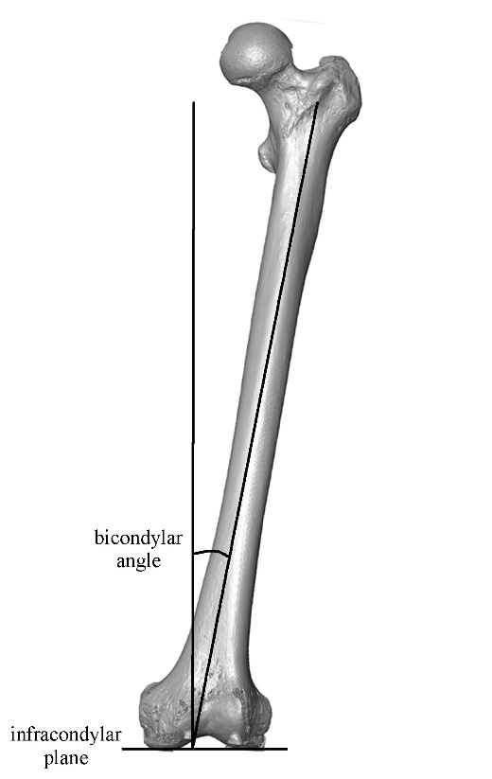
Figure 5. Measure of bicondylar angle.

Human Chimpanzee Gorilla

Which species has the greatest bicondylar angle? ________________________________
_________________________________________________________________________

Given your answer to the previous question, complete the following sentence by selecting the appropriate term:

‘Bipedalism created the need to be balanced while standing. To do so, the centre of gravity needs to be sustained over each leg reciprocally during walking. Therefore, in the human femur the bicondylar angle is more important/less important than in African apes so that knees and feet are directly under the body’s centre of gravity to maintain balance while walking upright.’

4) Effective stride length for energy efficiency

The linea aspera and bipedalism
Another important feature of the femur related to bipedalism is the linea aspera (Fig. 6). The linea aspera is the attachment site for the hamstring muscles, which are powerful extenders of the hip joint. Using the 3D models, take a screen shot of the posterior view of the femur and paste it below.
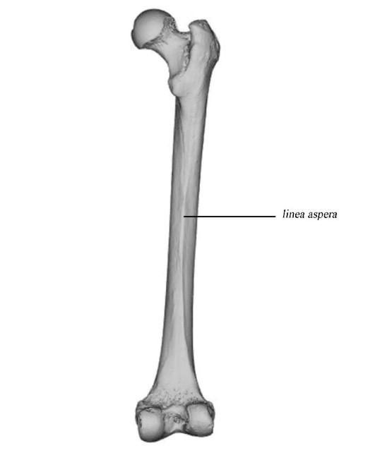
Figure 6. Identification of the linea aspera.

Human Chimpanzee Gorilla

Which species has the most prominent linea aspera? ________________________________
__________________________________________________________________________

Given that the linea aspera is the attachment site for the hamstring muscles, what activities might lead to a pronounced linea aspera? ________________________________________
__________________________________________________________________________

In each 3D model, measure the ratio of lateral antero-posterior diameter and supero-inferior diameter of the lateral condyle as shown in Figure 7 and enter it in the table. Then calculate the ratio of these two measurements.
Species | AP diameter (mm) | SI diameter (mm) | Ratio (AP/SI)
Human
Chimpanzee
Gorilla

Which species has a more elliptical morphology (i.e., a higher ratio) of the distal condyle of the femur?____________________________________________________________________
__________________________________________________________________________

The elliptical morphology of the distal condyle of the femur maximizes the area of contact at the knee joint when the knee is in extension and thereby widely distributes the load on the knee.

Which species has a distal femur better adapted to knee extension?____________________
__________________________________________________________________________
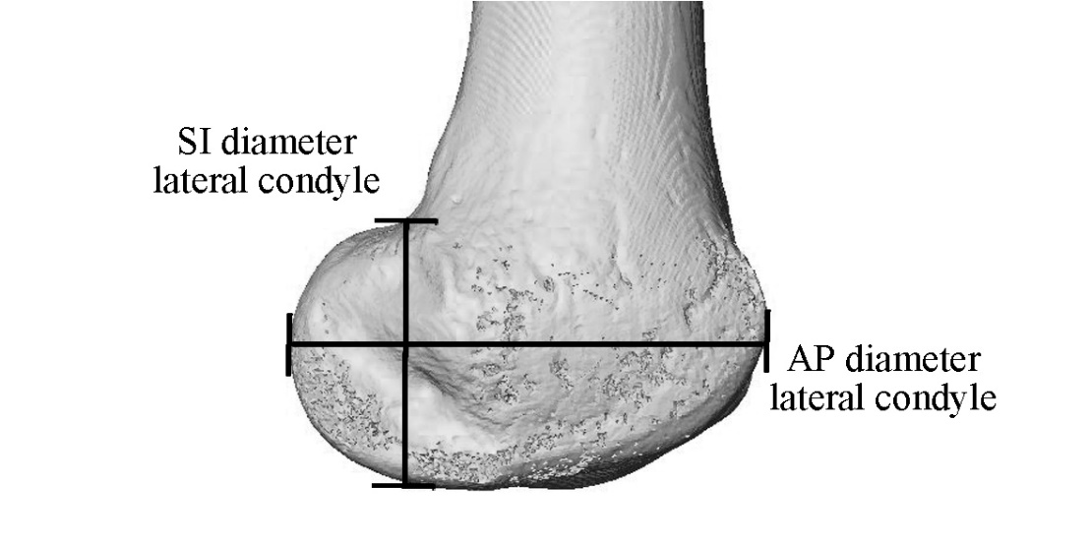
Figure 7. supero-inferior and antero-posterior diameters of the lateral epicondyle.

Indeed, having a long, vertical femur and full extension of the knee become advantageous in bipedal gait because it increases effective leg length, as such increasing stride length (see Fig. 1).

Helpful references:
Aiello, L., & Dean, C. (1990). An introduction to human evolutionary anatomy. Academic Press.
Hogervorst, T., & Vereecke, E. E. (2014). Evolution of the human hip. Part 1: the osseous framework. Journal of hip preservation surgery, 1(2), 39-45.
Lovejoy, C. O. (2007). The natural history of human gait and posture: Part 3. The knee. Gait & posture, 25(3), 325-341.
Ueno, H., Suga, T., Takao, K., Miyake, Y., Terada, M., Nagano, A., & Isaka, T. (2019). The Potential Relationship Between Leg Bone Length and Running Performance in Well‐Trained Endurance Runners. Journal of Human Kinetics, 70(1), 165-172.

